

Fixed-wing Operations v14

1. Introduction

1.1 The Redhill Aerodrome Traffic Zone (ATZ) is divided into two sections (i) the helicopter circuit and (ii) the fixed-wing circuit area. The dividing line is orientated according to the runway in use and extends to the boundary of the ATZ. Fixed-wing aircraft shall not fly within the helicopter circuit area unless it is an emergency or authorised by ATC.

1.2 All procedures are based on the QNH. The QFE will only be provided if requested by a pilot.

1.3 All aircraft must either have a serviceable transponder or obtain an exemption from the Aerodrome Manager. Note: Aircraft operating with an exemption are prohibited from using Runway 18/36.

1.4 Operations will normally be conducted under Visual Flight Rules (VFR) observing the minima applicable to Class D airspace below 3000ft AMSL and less than 140kts IAS.

1.4.1 Fixed-wing aircraft: minimum meteorological visibility 5000m, clear of cloud and with the surface in sight.
Helicopters: minimum meteorological visibility 1500m, clear of cloud and with the surface in sight.

Note: when the weather conditions observed by Redhill ATC are below these values Special VFR operations may take place, see paragraph 15.

1.5 An Air Traffic Control Service, callsign Redhill Tower, is provided between the 0900 -1900 hours local (summer) and 0900-1700 hours local (winter) and at other times as required by the Aerodrome Licensee.

2. Taxying

2.1 Fixed-wing taxying is restricted to paved taxyways, runways and the grass areas north of Runway 07R/25L and east of the H18/H36. Pilots must exercise caution when taxying on the grass, especially west of Runway 18/36 where the surface is uneven. Grass areas, including the unlit runways, are only available between sunrise and sunset.
2.2 Fixed-wing aircraft must not vacate a runway until instructed to by so ATC.

2.3 Specific clearances to cross a runway that is not in use will only be issued where the taxy route crosses the runway between the marked thresholds.

Note: for ATC and licensing purposes Runways 07L/25R and 07R/25L are treated as one; they cannot be used contemporaneously. A specific clearance to cross Runway 07L/25R will only be issued when it is in use as a runway.

2.4 Fixed-wing aircraft taxying must cross Runway 18 south of the displaced threshold.

2.5 Fixed-wing aircraft are to enter/exit Taxyway E south of the entrance road to the Terminal Building.

2.6 Rwy 18 – when the grass is serviceable all departures will be from Hold G3. Pilots requiring the full length must inform ATC. Full length departures will enter via G3, back track and line-up. Aircraft requiring the full length may expect a delay.
Note: Holding Points H1 and H2 will not normally be available when the grass is serviceable to minimise interaction between fixed-wing aircraft, helicopters and motor vehicles.

2.7 Rwy 36 – From Hangar 9, 8 or 6 taxy to G3, when instructed cross the runway and then join Taxyway E south of the entrance road to the Terminal Building then continue to C1 or as instructed by ATC.

From Redhill Aviation taxy to D1 via Taxyway D. Caution helicopters arriving and departing via H36.

2.8 When taxying on the grass remain well away from the Air Ambulance Hangar (Hgr 10) due to possible helicopter downwash.
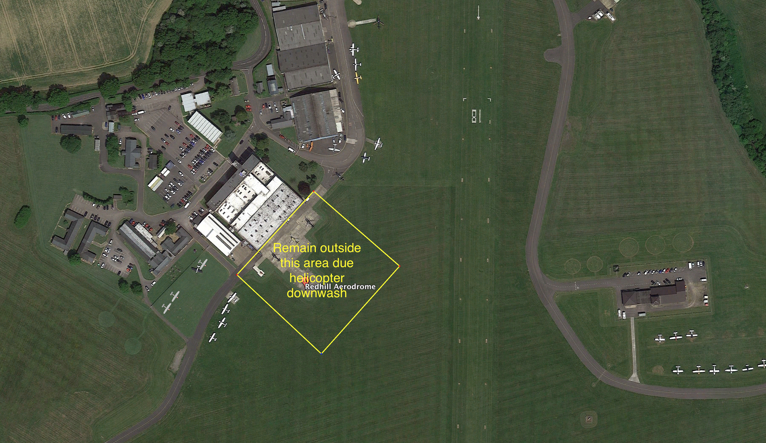

2.9 When positioning for refuelling on Taxyway F, unless ATC have specified an entry point (FS or FN), always park into wind. This ensures any spillages/fumes are blown away from the fueller.

3. Hand-swinging Aircraft

3.1 Unless procedures have been agreed with the Aerodrome Manager pilots are not permitted to start an aircraft, anywhere on the Aerodrome, by hand-swinging the propeller without a competent person, suitably briefed, either at the controls or swinging the propeller.

3.2 Pilots must comply with the guidance issued by the CAA Safety Sense Leaflet 1e (2013). Failure to comply with this will result in permission to use the Aerodrome being withdrawn.

4. Circuit Procedures

4.1 Fixed-wing aircraft shall fly the following circuit patterns:

Runways 36 and 25 right-hand circuit
Runways 07 and 18 left-hand circuit

remaining within the ATZ and south of the A25 Nutfield – Bletchingley road.

4.2 Runway 07 – climb straight ahead, commence the crosswind turn after passing to the south of Henhaw Farm. See Appendix 2.

4.3 Runway 25 - climb straight ahead, commence the crosswind turn over the middle of Benting Wood. See Appendix 2.

4.4 Runway 18 - Make a left turn at Axes Lane/Green Lane to track parallel with Rwy 07R on crossing the M23 a slight right turn to join the Redhill/Tonbridge railway line and follow it to Godstone Railway Station. Note: avoid turning too early and overflying South Hale Farm. See Appendix 3.

4.5 Runway 36 - the base-leg turn must be made immediately on passing Burstow Park Farm to track parallel with Rwy 25L. See Appendix 3.

Caution: Runway 18/36 is a tight circuit and may not be suitable for student or inexperienced pilots in strong winds.

4.6 There is NO DEADSIDE - helicopters fly a circuit pattern opposite to that used by fixed-wing aircraft. Circuit altitude 1200ft QNH.

4.7 In the event of a go-around remain within the fixed-wing circuit area i.e. north of Runway 07R/25L or east of Runway 18/36.

4.8 The maximum number of fixed-wing aircraft permitted to fly circuits at any one time is restricted as follows: Runways 07, 18 and 25 - 4, Runway 36 – 3.

4.9 The fixed-wing circuit will be closed if the reported meteorological visibility is less than 5000m and/or the cloud ceiling (BKN) is below 1,000ft. ATC may also restrict the numbers of aircraft in the circuit if they cannot maintain visual contact with aircraft throughout the circuit pattern.

4.10 Flapless and glide approaches must be requested and are subject to ATC approval.

4.11 Practice fan-stops are permitted in the climb out from Runway 07L/R; these are restricted to 3 per detail per aircraft. Pilots are to call the R/T prior to commencing the exercise and to report climbing away. From all other runways the exercise will be simulated by initiating a go-around on final approach and completing the exercise over the Aerodrome.

4.12 If required to carry out an orbit in the circuit this will be made in the circuit direction.

4.13 Care must be taken on approach and departure from all runways not to drift into the helicopter circuit area. ATC will warn pilots of helicopter circuit activity by informing joining pilots “…the helicopter circuit is active.”
4.14 Pilots should note that helicopters flying under VFR in the visual circuit pattern operate a semi-passive RTF system. ATC issue positive take-off clearances to assist with deconflicting helicopters and fixed-wing in the climb-out area. Helicopter pilots make position/intention reports primarily for situational awareness of other pilots; these calls are acknowledged by ATC however no further action is taken unless ATC detects an unsafe situation developing.
4.15 Positive control of helicopters will be provided by day when SVFR operations are taking place or when Runway 06/24 is in use and at night.
5. Visual Reference Points (VRPs)

ATC will require all aircraft to route via one of the following VRPs depending on the runway in use:

Visual Reference Point | Lat/Long (WGS84)
M25/M23 Junction (junction of M25/M23 motorways) | 511550N 0000741W
Godstone Junction (junction of A25 and B2236 roads) | 511450N 0000401W
Godstone Railway Station (Godstone Railway Station) | 511305N 0000304W
Buckland (Buckland Lake) | 511424N 0001445W

6. Departures

6.1 The following VFR routings will be issued by ATC to departing fixed-wing aircraft:

Runway 07 | Runway 25
East – Godstone Railway Station VRP | East – Godstone VRP
West & North – Junction VRP | West & North – Buckland VRP
Runway 18 | Runway 36
West & North – Junction VRP | West – North of Reigate
East – Godstone Railway Station VRP | East – Godstone VRP

6.2 ATC will issue the outbound routing together with an altitude restriction to the aircraft at the holding point prior to issuing of a take-off clearance. This must be read back. Aircraft unable to comply with these routings or requiring an alternative routing must inform ATC prior to departure.

7. Arrivals

7.1 Inbound fixed-wing aircraft are to monitor the ATIS (125.305MHz) prior to establishing contact with Redhill ATC on 119.605 MHz at least 5 minutes before their ETA at the appropriate VRP. This enables ATC to pass traffic information and plan the join.

7.2 The standard VFR routings are:

Runway 07 | Runway 25
East – Godstone VRP | East – Godstone Railway Station VRP
West & North – Buckland VRP | West & North – Junction VRP
Runway 18 | Runway 36
West & North – North of Reigate | West & North – Junction VRP
East – Godstone VRP | East – Godstone Railway Station VRP

7.3 Fixed-wing aircraft operated by based Flying Training Organisations will not be given a straight-in approach unless specifically requested by the pilot in command.

Useful tip: Overhead Joins – enter the ATZ parallel with the runway in use aiming to fly directly over the Tower.

8. Holding Outside the ATZ

Contrary to MATS Part 1 Section 3 Chapter 1 Redhill ATC may require an aircraft to hold (or orbit) at a VRP before entering the ATZ. Normally only one aircraft should be held at a VRP however, if it is necessary to hold more than one aircraft at a particular VRP traffic information will be passed to all pilots concerned. Pilots are responsible for deciding the direction to orbit.

Aircraft operating VFR will not be held at Buckland (Runway 07) or Godstone Railway Station (Runway 25). Pilots routing via these VRPs will be given an overhead join.

9. Practice Fan-Stops

Practice fan-stops are permitted in the climb out from Runway 08 however; these are restricted to 3 per detail per aircraft. Pilots are to call the R/T prior to commencing the exercise, this call will be acknowledged by ATC with the instruction to report climbing. From all other runways the exercise will be simulated by the instructor initiating a go-around on final approach and completing the exercise over the Aerodrome.

10. Automatic Terminal Information Service (ATIS)

10.1 The ATIS provides pilots with weather and aerodrome information. Each broadcast has a code letter and pilots are required to monitor the ATIS; acknowledge the information received on first contact with ATC and include the QNH.

10.2 Pilots must listen the ATIS on frequency 125.305 MHz or via telephone 01737 822947 before contacting ATC.

10.3 Outside ATC hours the information is compiled automatically and therefore not checked for accuracy. The broadcast states “This is Redhill Information (code letter) time ____ Automatic…..”

Pilots must be aware of the limitations of automatic meteorological observing equipment.

10.4 Runway Condition Codes are not available outside ATC hours.

11. Use of Unlicensed Runway 06/24

11.1 A section of taxyway C/D is marked as an unlicensed runway: Runway 06/24 498m x 10m. See Appendix 4 for circuit pattern.

11.2 Use of the unlicensed runway is subject to a Section 106 agreement with the local planning authority. The main operational conditions set out:
- Not at any time to use any part of Taxyway C/D (including the Unlicensed Runway) for any Flight Movement* (other than in the case of emergency or damaged aircraft) unless:
- the Grass Runways are Unserviceable; or
- if no Grass Runway is available due to weather conditions, waterlogging, obstruction, regulatory requirement, emergency reasons or safety reasons.

*take-off and landing of a fixed-wing aircraft including Touch and Go and emergency landings.

- Between 1 November and 31 March each year no more than an average total of 85 daily fixed-wing movements permitted to occur assessed on a rolling seven-day average basis.

11.3 The daily movement limit will be managed by ATC, on a tactical basis, by restricting touch and goes.

11.3.1 When touch and goes are restricted full stop landings with a backtrack for further circuits will also be prohibited.

11.4 The following operational restrictions apply to the use of this unlicensed Runway 06/24:

i) The runway is only available when the grass runways are unserviceable.

Ii) ATC will ensure that any Group 1 helicopter is no closer than 60m and any Group 2 helicopter is at least 120m to the edge of the taxyway.

iii) Any helicopter in the Eastern Hover Square must remain on the ground whilst a fixed-wing is departing on Runway 06 or landing on Runway 24.

- Any helicopter in the Southern Hover Square must move to the northern edge and remain on the ground whilst a fixed-wing movement takes place.

- Any helicopter in the Western Hover Square must remain on the ground whilst a fixed-wing is landing on Runway 06.

12. RTF Procedures

12.1 Outbound: “Redhill Tower (callsign) outbound Information ___ QNH ____” or
Fuel: “Redhill Tower (callsign) request taxy fuel.”

12.2 When ATC say ‘Pass your message” give the following details:
“(callsign) or (registration if different to callsign) (type), (POB), (parking area) request taxy for (local east or west/destination/circuits*)” *as appropriate. DO NOT include SSR code, wait for ATC to issue it.

12.3 Inbound - Initial contact at least 5 minutes prior to a VRP (inbound from another aerodrome): “Redhill Tower (callsign) inbound Information ___ QNH______.”

12.4 Re-joining from local flying: “Redhill Tower (callsign) re-joining from (direction) Information __ QNH _____.” This transmission shall be made 5 minutes prior to the inbound VRP.

12.5 Please ensure that you read back mandatory instructions/information
(i) taxy instructions
(ii) altitude instructions
(iii) runway in use
(iv) clearance to enter, land, take-off, backtrack, cross or hold short of any active runway
(v) altimeter settings
(vi) frequency changes
(vii) route clearances
(viii) SSR code.

A full list is set out in CAP413 Radiotelephony Manual.

12.5 ATC are required to ensure that pilots read back these items. When pilots do not comply ATC have to make additional transmissions until a read back of all the applicable items has been obtained.

13. Noise Abatement Procedures

13.1 The Aerodrome Licensee publishes certain local procedures or restrictions designed to minimise the nuisance caused to local residents. These are:

(a) Aerobatic manoeuvres are prohibited within the Redhill ATZ.

(b) Runway 07R/25L is the preferential runway.

(c) Comply with the published circuit patterns

(d) Multi-engine fixed-wing aircraft may only use Runway 18/36 when the surface wind precludes the safe use of Runway 07R/25L.

(e) Circuit training by multi-engine fixed-wing aircraft is not permitted on Runway 18/36.

(f) Circuit training by multi-engine fixed-wing aircraft, except night flying, is not permitted after 1830 hours local time or at any time on a Sunday.

14 Helicopter Operations

14.1 Helicopter operations by single engine piston/turbine and medium/heavy multi-engine turbine helicopters take place at Redhill - caution wake turbulence.
14.2 Air taxying helicopters direct a forceful blast of air downwards which rolls out in all directions. Also, when a helicopter's weight is transferred from the landing gear to the rotor a strong downwash is created. Fixed-wing aircraft must not be park close to helicopter aprons or stands.
14.2.1 Fixed-wing pilots operating from EBG Helicopters (Hangar 6) must pay particular attention to where they park their aircraft. Fixed-wing flying controls are easily damaged by helicopter downwash.
14.3 ICAO divides helicopters into groups according to their MAUW. The helicopter groups, their wake turbulence classification together with the dimensions of the largest helicopter in each group is set out below.

ICAO Helicopter Groups/Wake Turbulence Categories

Group 1 | Wake Turbulence Category
Max overall length: 13m | Light
Group 2 | Wake Turbulence Category
Max overall length: 17m | Light
Group 3 | Wake Turbulence Category
Max overall length: 23m | Small

14.4 Fixed-wing pilots should maintain a distance of at least 3 x the rotor diameter from a helicopter. The maximum overall length in the table is based on the largest helicopter in each category; pilots may use this information as a guide to the distance required between themselves and a helicopter
15. Special VFR (SVFR) Operations
15.1 When the weather conditions reported by Redhill ATC are below those set out in paragraph 1.4 fixed-wing and helicopters will offered SVFR clearances with the ATZ.
15.2 SVFR operations are only available from Runway 07R/25L. The runway lighting will be switched on whenever SVFR flights are taking place.
15.3 The minimum weather limits for SVFR at Redhill are:
 | Visibility | Cloud Ceiling
Fixed-wing | 3000m | BKN007
Helicopter | 800m | BKN007

A General Exemption permits Police, Helimed, Rescue, Electricity, Grid, Powerline, Rail Track or Pipeline callsigns to operate SVFR below the minima set out above.
15.4 ATC is required to provide standard separation between SVFR flights and between VFR flights and IFR flights; it is important that pilots inbound to the Aerodrome contact ATC at least 5 minutes prior to any VRP.
15.4.1 ATC will normally achieve separation by either maintaining visual contact with each aircraft or by asking each aircraft if they are visual with each other. If pilots report visual and are able to accept visual separation they become responsible for ensuring they remain clear of each other.
15.4.2 If either pilot is not visual then aircraft will be held until ATC can ensure they are separated.
15.5 Pilots must follow the inbound/outbound routings set out in paragraphs 6 and 7.
15.6 Pilots requesting to use the Aerodrome when the weather is below VFR limits will be assumed to be able to operate SVFR.
15.7 A pilot operating SVFR:
a) must comply with ATC instructions
b) is responsible for ensuring that the flight conditions enable them to remain clear of cloud, determine their flight path with reference to the surface and keep clear of obstructions
c) ensure they fly at an indicated airspeed of 140kts or less in order to provide adequate opportunity to observe any obstacles in time to avoid a collision. SERA.5010(b)(3) refers
d) is responsible for ensuring they fly within the limitations of their licence
e) is responsible for complying with the Rules of the Air Regulations low flying restrictions (other than the 1000ft rule)
f) is responsible for remaining outside an ATZ unless prior permission to enter has been obtained from an ATC Unit. CAP 493 MATS Part 1 Section 1 Chapter 2 refers.
15.8 Redhill ATC will issue a specific clearance for each flight flying within the ATZ/LFA.
Outbound: “(callsign) after departure leave via (VRP) not above (altitude) SVFR.”
Inbound from VRP: “(callsign) clear to enter the Redhill ATZ not above (altitude) SVFR report (circuit position).”
15.9 Fixed-wing circuit flying is not permitted under SVFR.
15.10 Arriving aircraft shall take priority of departing aircraft.
15.11 When the meteorological visibility consists of two values, the lower of the two values shall be used when determining if a SVFR clearance can be issued. (MATS Part 1 Section 1 Chapter 2 Flight Rules refers).

16. Fixed-wing Operations Outside the Published Aerodrome Hours

16.1 Use of Redhill Aerodrome outside the published closing times is restricted to operators who have obtained prior permission from the Aerodrome Manager, have a valid Out of Hours Permit and comply with the conditions stated within the Permit.

16.2 Due to uncontrolled works (grass cutting and sweeping) that take place prior to ATC opening fixed-wing Out of Hours Permits are only valid for the period 1900 – 2200 hours local (summer only).

16.3 Departures prior to 0900 hours local require prior from ATC who will advise if this will be possible. ATC attendance may be required and a charge will be levied.

16.4 Prior notification must be given to Redhill ATC via email: ooh@redhillaerodrome.com of the intention to operate outside ATC hours. Details must include registration, POB destination or point of departure and ETA/ETD. A second email must be sent once the flight has been completed with ATA/ATD and runway used.

16.5 Except for NPAS or AAKSS flights that have obtained specific permission from the Aerodrome Licensee training, circuit flying or maintenance flights are not permitted.

17. Out of Hours Arrival and Departure Procedures
17.1 All departures and arrivals are to be flown so as to remain within the Redhill ATZ which is designated as active H24. Rules applicable to VFR Class D airspace apply. Permission to fly within the ATZ is granted when the permission to operate outside ATC hours is granted. SVFR operations are not permitted.

17.2 Inbound pilots must carry out an overhead in order to satisfy themselves that that runway and taxyways are not obstructed.

17.3 Flights must not enter the Gatwick CTR/CTA unless a positive clearance has been obtained from Gatwick ATC. Specific procedures apply for emergency service helicopters.

17.4 The ATIS will broadcast the Runway in Use either 07R or 25L.

17.5 Pilots must make standard inbound and outbound broadcasts of their intentions on 119.605 MHz including changing frequency. This information must include the runway they are using. CAP413 page 61 refers.

17.6 Pilot Activated Lighting (PAL) is available. Details are provided on the Out of Hours Permit.

17.7 Fixed-wing arrivals and departures are restricted to Runway 07R/25L.

17.8 Unless there is an overriding flight safety or operational requirement pilots must comply with the standard arrival and departure routes.

17.9 Unless operating on a discrete SSR code pilots must select SSR code 7012 and monitor Gatwick Director 126.825MHz.

17.10 Helicopters use the Aerodrome H24. The Air Ambulances, callsign Helimed 60A and Helimed 21A, together with the Police helicopter, callsign Police 37, must be afforded priority over arriving or departing fixed-wing.

18. Hi-Visibility Clothing

18.1 This is only required to be worn during daylight hours by persons, on foot, on the runways/taxyways and by pilots/ops staff engaged in helicopter rotors-running or fixed-wing engine running crew/passenger change overs. It is not required on apron areas.

18.2 At night all pilots/ops staff on foot must wear high visibility clothing on taxyways, runways and aprons.

Philip Wright
Aerodrome Manager/SATCO 08.11.2022

Appendix 1 – Aerodrome Layout

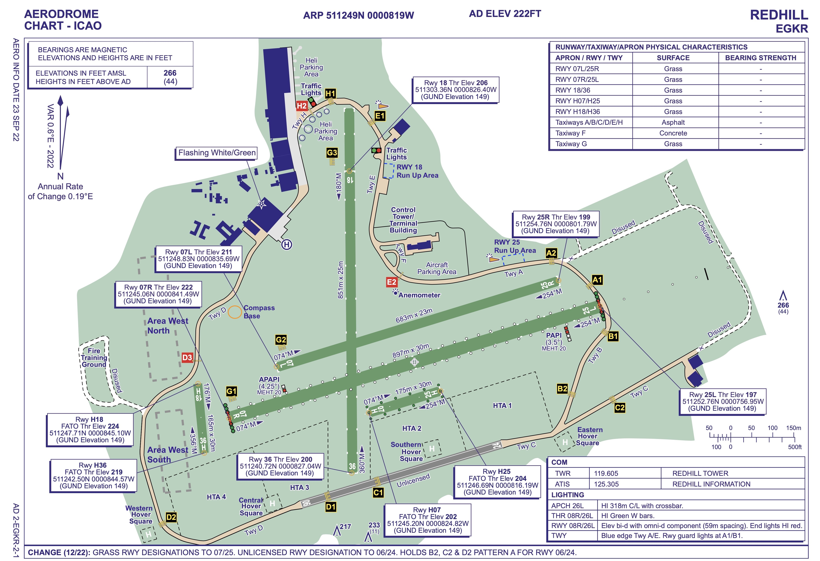

Appendix 2 – Runway 07/25 Circuit Patterns

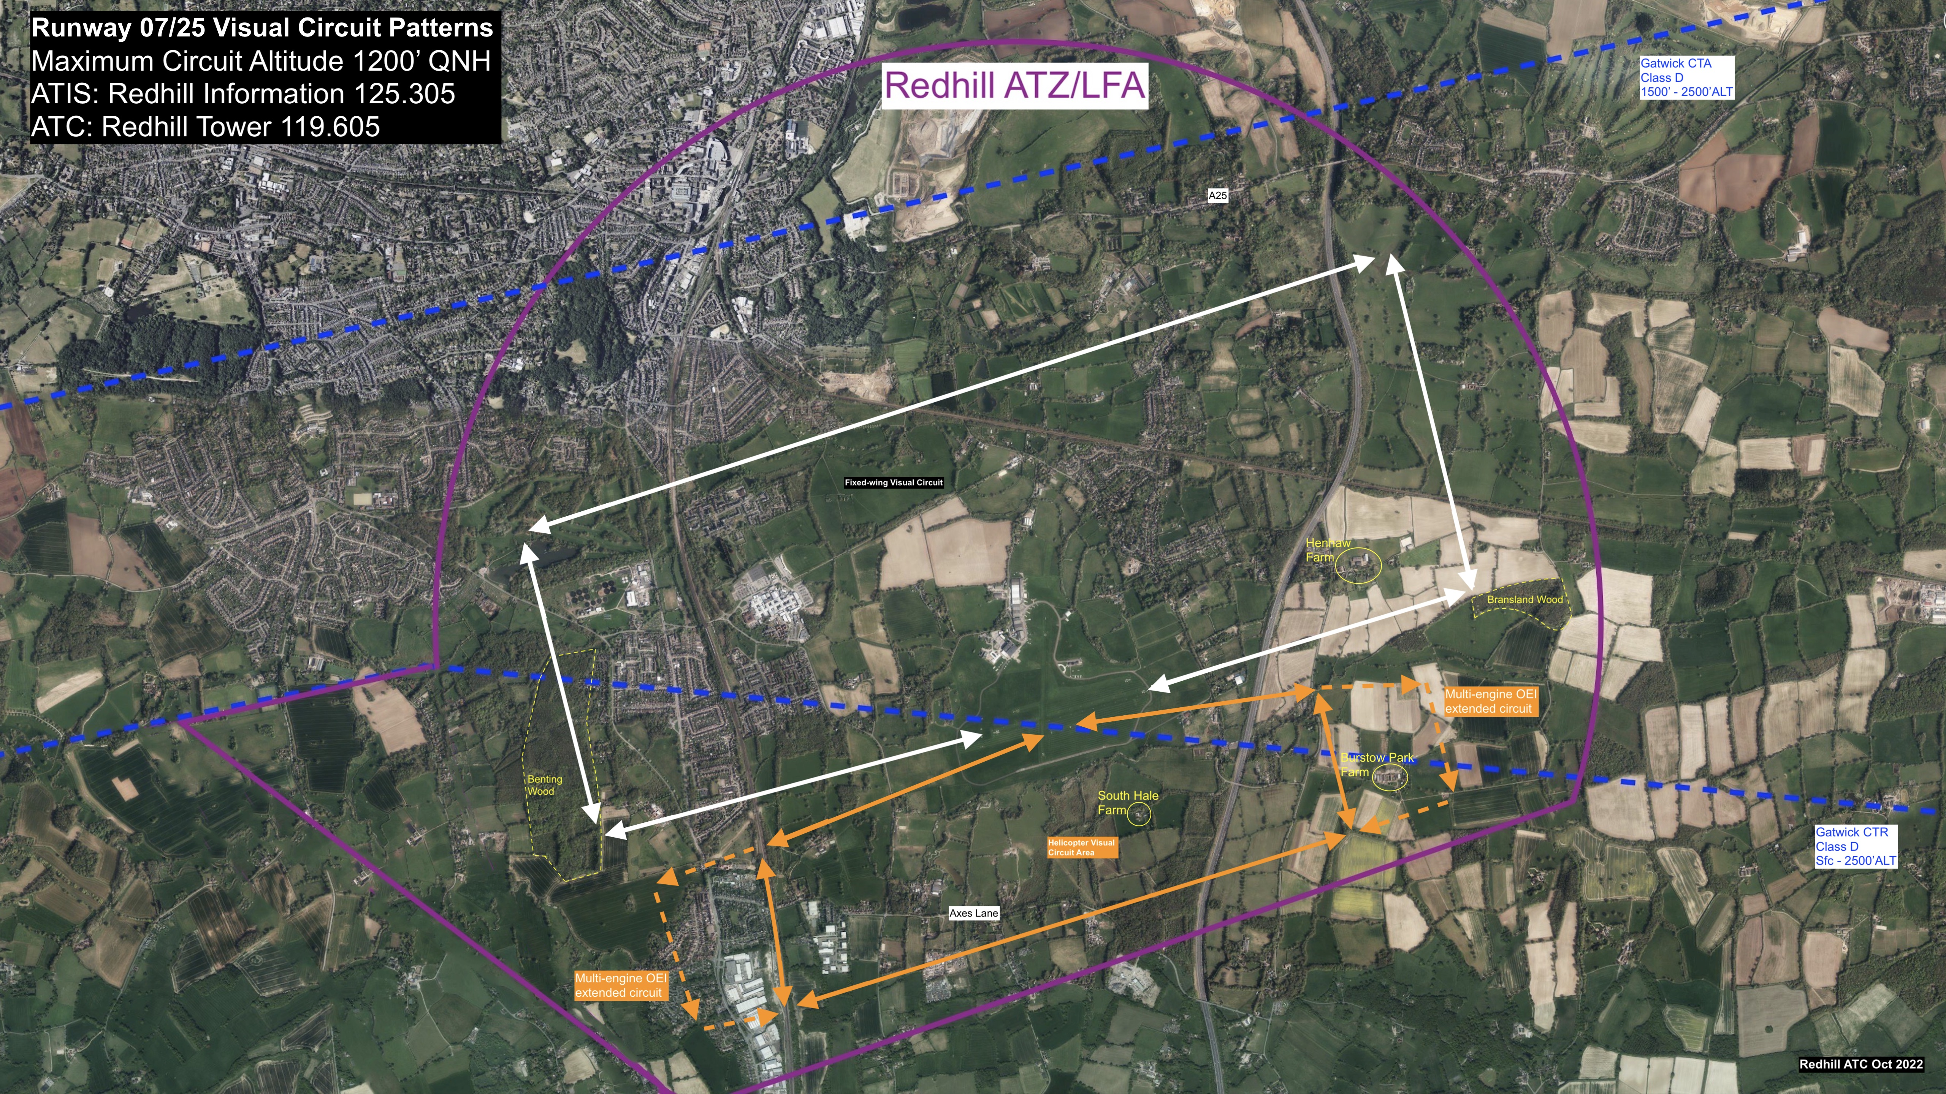

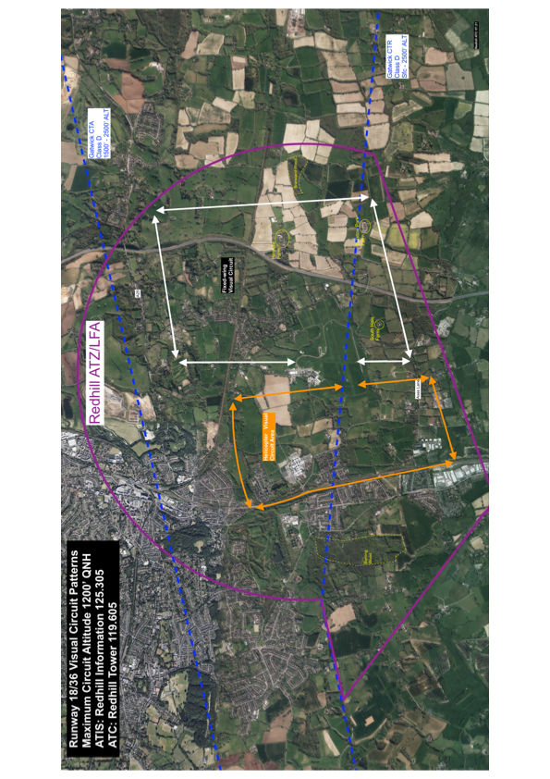
Appendix 3 – Runway 18/36 Circuit Patterns

Appendix 4 – Runway 06/24 Circuit Pattern

